**Project Description**

In this age of globalization everyone needs to be aware of events occurring around them and tech minds are working on ways to provide quick and effective information to people with less hassle. If we talk about businesses nowadays, the success of their business and popularity of their products is highly dependent on promotional activities. So, every vendor nowadays is looking for efficient ways for promoting their products. As we are moving ahead in this age of technology new inventions are being made and technology is becoming easily accessible to everyone. So, taking advantage of this point, this FYP is motivated to bring modernity and efficiency in marketing techniques used nowadays. We are working on context-based marketing which will target specific people based on their location.

**Project Work Breakdown Structure:**

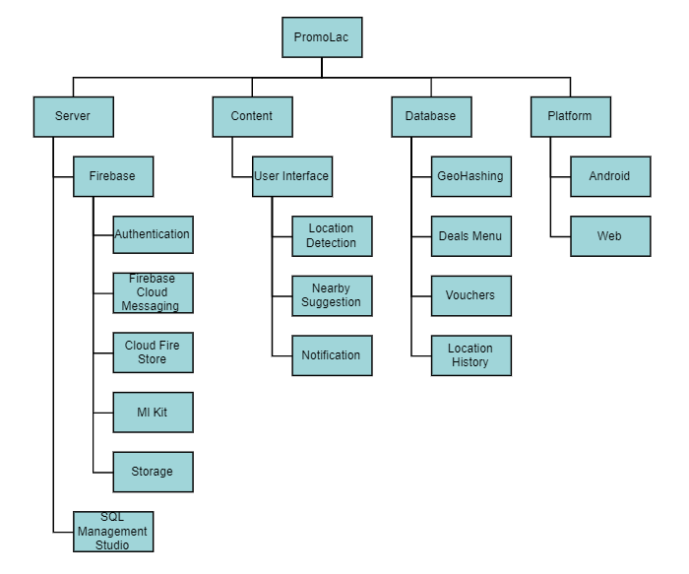

**Gantt Chart**

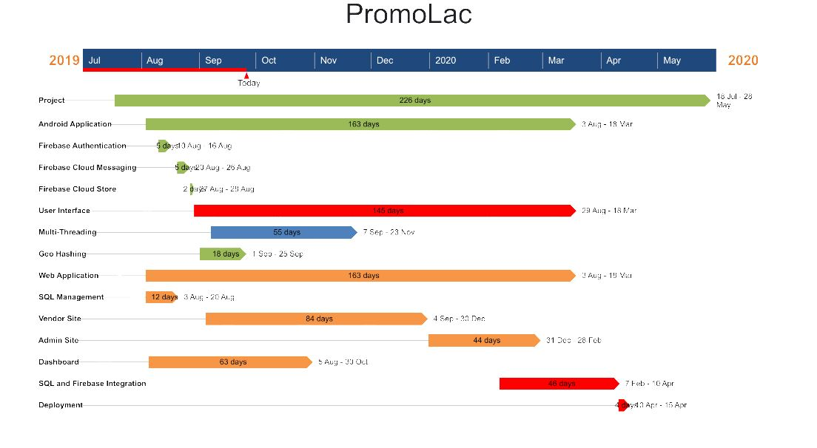

**Work that was completed till FYP-1 evaluation**

* The user side (Android Application) was completed approx. 60 percent
* The connection with the firebase was maintained
* The full UI of the Android was completed
* In Android the Nearby and Map feature was completed
* The Vendor Side (Web Application) was completed approx. 40 percent
* The location services code was written

**Work done from FYP-1 evaluation till mid-evaluation date**

* The notification generation was completed to provide message and push notifications
* The Message View was completed
* Application size was reduced to about 16 MB
* The Notification Log was completed approx. 50 percent
* The Location Services Algorithm was improved, now the current algorithm will perform better in term of battery and performance up to 60%
* The data collection from firebase to csv was created for the training of offline location prediction model
* Application was putted in the testing phase and the data collection process was started
* Admin side was completed approx. 45%
* The Middleware between firebase and SQL Server was created
* The project was semi deployed and will be able to work in Procom and DevDay

**Schedule or Plan for remaining work till FYP-2 final defense**

* Making an efficient model for offline location prediction
* Completion of Admin panel
* The Project will be deployed
* The Project will be tested
* The performance of Application will be improved by replacing Activity by Fragments